Department | FED
Subject | DSA-2
Academic Year | I-III Semester(2025-26)
Faculty Name | BALAIAH SIR
Student Name | V.CHARISHMA
Roll Number | 2520030140
Branch | CSE
Course Outcome

Case Study Topic: MediFlow Hospital Appointment-Driven Patient Indexing using BST and AVL Tree
Work Done Summary:
In this case study, we analyzed patient indexing in MediFlow Hospital using Binary Search Trees (BST) and AVL Trees.
Patient IDs were inserted in appointment order:
20, 30, 35, 40, 45, 50, 60, 65, 70, 75, 80, 85, 90
Since the IDs arrive in nearly sorted order, the plain BST becomes highly unbalanced and resembles a linked list. We then constructed an AVL Tree using the same insertion sequence and observed automatic balancing through rotations.
We also applied deletions of patient IDs 30, 70, and 50 and compared the performance of BST and AVL Trees with respect to lookup efficiency and SLA constraints.
Implementation Details:
- Inserted patient IDs into a Plain BST following appointment order.
- Observed that the BST became right-skewed because IDs arrived in ascending order.
- Calculated BST height and worst-case lookup time.
- Constructed an AVL Tree using the same insertion sequence.
- Performed AVL rotations whenever balance factor exceeded ±1.
- Recorded LL, RR, LR, and RL balancing operations.
- Applied deletions: 30, 70, and 50.
- Rebalanced the AVL Tree after deletions.
- Compared lookup performance of BST and AVL Trees.
- Verified compliance with the hospital's 5 ms lookup SLA
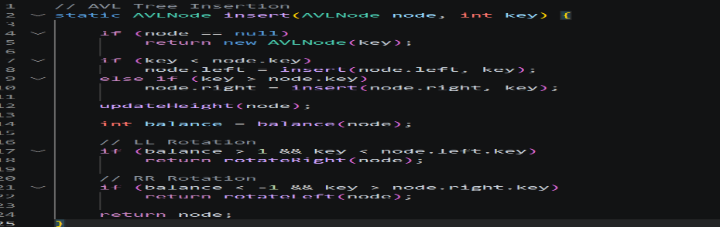
Result: Screenshots / Output
The AVL Tree successfully maintained balance during insertion and deletion operations.
Time Complexity : AVL Insert/Delete: O(log n) AVL Search: O(log n)
Compared to a plain BST, AVL Tree offers faster and more efficient lookups.
